**Virtual Quality Control Robot Electrical System**

**White-Paper Updated – April 12, 2021**

**ARMFLEX 9000 team member, Michael Aono, University of British Columbia, Vancouver, BC**

**Abstract**

A driver system is developed to power the motors of the Quality control robot. The quality control robot is capable of three and a half DOF and is powered by 4 identical OTS graphite communicated motors. The torque requirements of the robot are met with the addition of planetary gear heads of reduction ratio 64:1 on the base arms. The driver system is of H-bridge form and outputs 11.1V to the motors from 5V input. A PCD design is of the driver is developed to create a mother-daughter board with the Ardinuo Leonardo.

In this paper, Section on describes motor selection. Section 2 describes driver design. Section 3 describes linear modeling of the drivers. Section 4 describes PCB layout of the design.

**Nomenclature**

DOF Degrees of Freedom

OTS Off-the-shelf

PCB Printed Circuit Board

K Gain

A Inverse Time Constant

CM Centimeters

CAD Computer-aided Design

**1. Motor Selection**

The motor selection is restricted to mechanically communicated Maxon and Faulhaber products. Included in the motor selection is the optical encoder and gearheads to meet the minimum torque requirements. The motor parts are selected with the goal of minimal weight and cost. All parts are selected from Faulhaber. The Series 2237-012-CXR with graphite commutation is selected for the motors, the Series IER3-10000 L is chosen for the optical encoders, and the 2 Series 26A planetary gear heads with a 64:1 reduction ratio are used for the base arms. The total cost for the motor parts comes to $1301.25 CAD (1041.62USD).

**2. Driver Design**

The motor drivers are designed in a H-bridge formation. The driver is constraint to supplying the motor with a voltage at or below the nominal voltage. The motor is rated for a nominal voltage of 12V and an input of 5V from the Arduino Leonardo, output 11.2V to the motor. The design of the driver is shown in Figure 2.1.

*Figure 2.1*

**3. Linear Modeling of Driver**

The driver’s step response given by Multisim is shown in Figure 2.2. Using the formula K*(A/s+A) the driver can be modeled as a first order transfer function. Using the step function in MATLAB and multiplying the input by 5 leads to an accurate model of the driver. This is shown in Figure 2.3

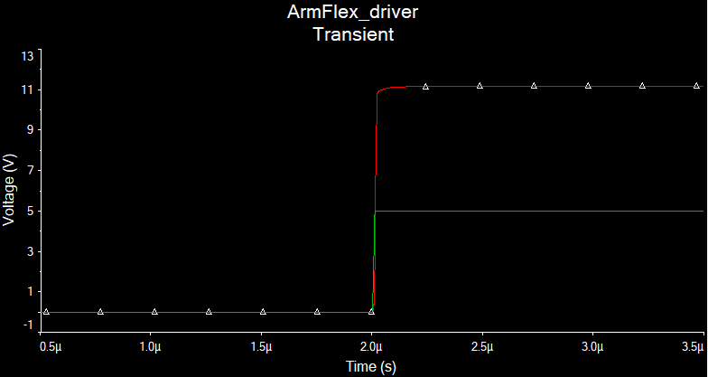

*Figure 3.1*

*Figure 3.2*

**4. PCB Design**

The PCB design of the drivers is restricted to one board. The design used in our project has all drivers a single board and has the dimensions 15CM x 7CM. The PCB is designed in a mother-daughter board configuration with mounting holes aligned to the holes of the Arduino Leonardo. The PCB board has a ground power plane on the bottom layer with minimal non-ground traces. The board is designed with power flow from right to the left. The board has 10 connectors, 8 for motor control, 1 for power and 1 for a ground connection. The Ultiboard model is shown in Figure 4.1. A CAD model of the top and bottom on the PCB are shown in Figure 4.2 and Figure 4.3 respectfully.

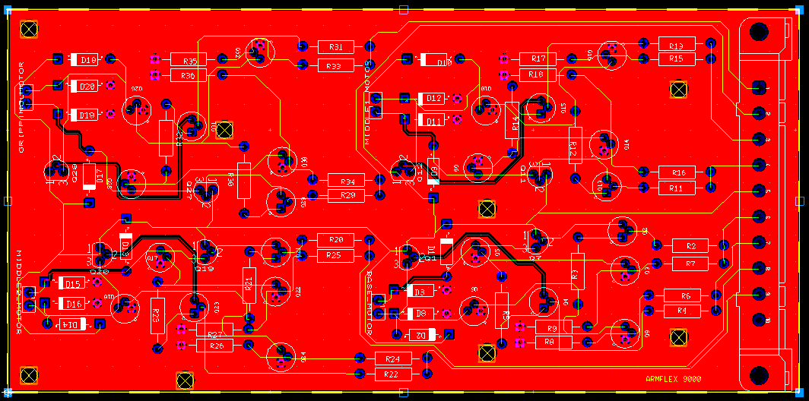

*Figure 4.1*

*Figure 4.2*

*Figure 4.3*